ASSIGNMENT 10.1

1. What qualities should a good Agile tester have?

Since agile is a Test driven development approach, the role of a Tester is very important and frequent. Testing is not done after all the modules are completed and signed off, as in traditional approach, but testing is more frequent in agile. The qualities of a good tester includes:
- knowing which test should be automated and which should not be
- choosing the right tools for testing
- execute test continuosly
- ensuring that time saved from automated testing are used optimally for other steps.
- Should have proper domain knowledge, knowledge about agile,..
- knowlede about testing only would not be nough, but he should be results oriented, craftsman-like, eager to learn, and should be passionate about delivering business value in a timely manner.
- Continuos feedback should be given
- he should ensure continuous integration
- if a bug is found, he should report it to the developer at the earliest
- should be active in scrum meetings
- should be good enough to priorotise test executions
- should be solution-oriented
- should always be sceptical in nature about the product
- should be accurate and give high value to quality
- in agile the changes will be rapid and hence the tester should respond quickly in adding, changing or modifying test cases
- work in collaboration
- should write comments wherever needed
- consider new actors/users other than normal users
- should have an open mind-set, should be creative and should give importance to details

2. What is Test Driven Development (TDD) and how much does it help add business value?

Test Driven Development or TDD is an apporach in which the development process is driven by testing i.e, testing is done in parallel during the development. The term was coined by Kent Beck in 2003.Traditionally testing was done once all the modules are completed and signed off and after that as a seperate phase. But this approach caused a lot of waste. i.e, even if a small change was to be made, then a review or relook to all had to be done and it was time consuming. Here a higher importance is given to quality. Testing is an integral part of development in this approach. Continuous Integration of the modules are also ensured here. Since agile focusses on Business value, a test driven approach is best due to few reasons. It reduces the defects. It reduces the total cost of ownership. Since the changes to the code can be done swiftly, there would be a better confidence.

TDD=TFD(Test First Design)+Refactoring (Refactoring makes small changes to the code without causing the changes to the entire development.)

3. What is CI? What is the effect of CI in schedule?

Continous Integration or CI is a very important practice done in agile, where multiple codes which may be written by different people or even multiple modules, will be integrated together continuously. Any changes made should be integrated continously because integration is very important for getting the output and desired outcome. CI focusses on giving rapid feedback so that if a defect is introduced into the code base, it can be identified and corrected as soon as possible. Continuous integration uses so many automation techniques like automated builds, automated testing and even immediate feedback to developers detailing any build errors or failed tests. Build failure test is one of the biggest problem, it should never occur. In CI, everything is automated, only the code is written manually. One of the key benefits of integrating regularly is that you can detect errors quickly and locate them more easily. CI avoids the last-minute chaos happening due to integration probelms. It also gives an early warning of broken code and conflicting changes. Spend less time debugging and more time adding features

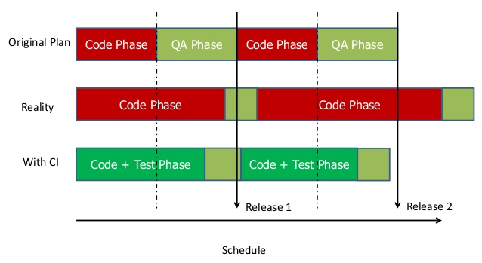

The above graph shows the comparison of time take for an orginal plan, the schedule taken in reality and the schedule when CI is used. Schedule won’t go as we planned in original plan, due to dynamic nature of the project and other factors. We can see that the releases happen late or not according to the schedule. This is becase code phase and QA phase are done seperately and code phase takes more time due to some internal or external factors. But when we implement Continuous Integration, more proactive and rapid the process becomes and instead of waiting, instant changes, integration etc are done and hence the time is utilised well. So the process takes even lesser time than the original plan. Using automation techniques is one reason why the time taken is less. And instead of coding same things repeatedly, where chances of making mistakes are high, automated tools help the team do things fast and the effort taken will be less.

4. What is Configuration management?
Configuration Mnagement is the practice of detailed recording and updating of information associated to the projects. It is necessary to record or update each working module or versions, so that it can be used later in case of bugs, errors or even to add features. Configuration management has an advantage that the entire collection of systems can be reviewed to make sure any changes made to one system do not adversely affect any of the other systems. It gives a detailed idea about what all items constitute the software. configuration management allows us to keep the record of what is being tested to the underlying files and components that make it up. This is very important. Let us take an example, when we there are some defects, we need to report them against something, something which is version controlled. If it is not clear what we found the defect in, the programmers will have a very tough time of finding the defect in order to fix it. CM is about knowing what we did yesterday, what we are doing today, and what we will be doing in the future, as well as understanding the reasoning and authority behind every action/change that got us there. Many organizations are dealing with hundreds to thousands of requirements, documents, drawings, test plans, etc. that are continuously changing. These items must be readily available, protected, and kept accurate at all times; meaning nothing should be changed without proper review and authorization. In addition, organizations must design, produce, deliver, operate, maintain, upgrade, and retrofit hundreds to thousands of their end-items, parts, assemblies, software programs, etc.

a. Name some sample tools available for version control?
- CVS
- SVN
- VSS
- CLEAR CASE
- GIT
- MERCURIAL
- BAZAAR
- MONOTONE

b. How does version control help in agile projects?
It is necessary for the team members to ensure that the versions/the releases should be maintained properly, so that its not lost or needed modifications can be done on the versions. If unexpected system crashes, or something bad happens it is necessary that the work done should be saved or backed up properly so that the effort wont go waste. Version Control tools ensure that the work done is saved properly so that they are safe as well as can be used as reference to modifiy or debug. In case of bugs also, the developers can easily find out and replicate so that bugs can be fixed. So in an ajile project where there would be dynamic changes, version control helps in modification, where the previous versions can be used for references. It may include all the codes, different management plans etc.. which we can go back and fetch later.
For example if A is a version and B is another version which has a part of the codes from A, tand changes need to be done in A then we can branch out the required part and edit it, without affecting tyhe other version B. Similarly it helps in manipulating different parts without affecting others which may have some parts in common. So as in when you write the working code, it should be checked in Version control tool.

5. Describe Automated Testing vs Deployment Automation

Agile is a time boxed practice and also a Test Driven Development approach. So we understand that here like the time, testing is also given high importance. So testing happens rapidly in agile with the development stage. So it is necessary to do it fast and hence the automation of testing was introduced which ensures that testing is done automatically, and saves time and reduces errors. In automated Testing a lot of test scripts needed to be written, but only one time test script. Traditional regression testing which is done manually would take lot of time and is a tidious task.Some kinds of test automation become cost effective only if the product under test is designed to facilitate testing or at least not designed to be exceptionally difficult to test. It helps to respond rapidly to requests for assistance from testers. Automated Testing includes automated unit testing, automated integration testing, acceptance testing etc.where most of the monotonous testing works are automated and efforts would be less. Automated test are reusable and can be used for codes, modules and more varying scopes. Risk of missing out predecided test is zero.

Deployement includes all the activities required to make a software system available for the user. So the project team which has the build need to put it in the production server, which is not an easy task. They have to stop all the processes for some period of time. Doing it manually takes a lot of time and hence automation of this reduces the time taken. Some automated deployement tools like octopus deploy, puppet labs etc.automaticallydeploy the build, if once it is metioned or setup how to deploy the build. Next time automatically the deployement happens and consumes very less time.
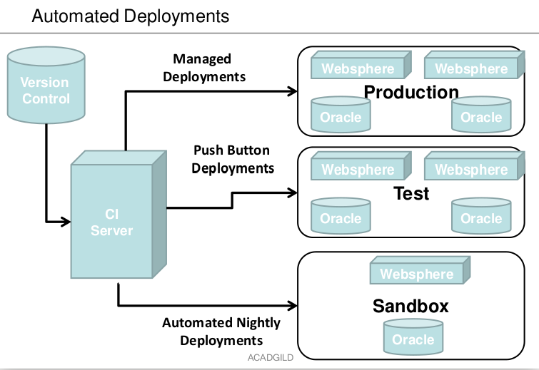

Automated deployement is done first in Sandbox, then test and finally production. Sandbox is a daily nightly deployement so that the team can know the previos days part is working or not. Then comes the Test which is done by a Push Button deployement and then the final Production where the deployement is done at the production server.

